**CHAPTER01**

**INTRODUCTION**

The 555 timer integrated circuit is an integral part of electronic projects. Whether it's a simple project involving a single 8-bit microcontroller and some peripherals or a complex involving a SoC, the 555 timer is involved. These provide time delays, as an oscillator and as a rocker element, among other applications.Introduced in 1971 by the American company , the 555 is still widely used because of its low price, ease of use and stability. It is manufactured by many companies in the original types of low-consumption, bipolar CMOS. According to one estimate, only one billion units were manufactured in 2003.

According to the manufacturer, the standard 555 package includes 25 transistors, 2 diodes, and 15 resistors on a silicon chip installed in an 8-pin dual-dual (DIP-8) package. The variants consist of combining several chips on a card. However, 555 remains the most popular. Let's take a look at the pin diagram to get an idea of ​​the timer IC before talking about timer 555 operation.

**CHAPTER 02**

**LITERATURE SURVEY**

The integrated circuit was designed in 1971 by Hans R.Camenzind under contract with Signetics, then acquired by Philips Semiconductors, now NXP.

In 1962, Camenzind joined the PR Mallory Physical Science Lab in Burlington, Massachusetts. He designed a pulse width amplifier (PWM) for audio applications [8], but it failed on the market because no power transistor was included. He was interested in tuners such as a spinner and a locked phase loop (PLL). Signetics hired him to develop a PLL integrated circuit in 1968. He designed an oscillator for PLL so that the frequency does not depend on the voltage or temperature of the power supply. Subsequently, Signetics laid off half of its employees due to a recession; The development in the PLL froze like this.

Camenzind proposed the development of a universal oscillator-based circuit for PLL and asked him to develop it on its own, borrowing the Signetics team instead of cutting his salary by half. Other engineers argued that the product could be constructed from existing parts; However, the marketing manager approved the idea. Among the 5xx numbers assigned to the analog integrated circuits, the reference number "555" was chosen.

Camenzind also taught circuit design at Northeastern University in the morning, attending university at night, with the goal of obtaining a master's degree in business administration. The first design for 555 was revised in the summer of 1971. Evaluated without error, the design was designed. A few days later, Camenzind came up with the idea of ​​using direct resistance instead of a constant current source and then discovered that it worked. The modification reduced the required number of 9 pins to 8, so that the integrated circuit could contain an 8-pin package instead of a 14-pin package. The 9-pin copy had already been published by another company founded by an engineer attending the first revision and having retired from Signetics; this company withdrew its version soon after the launch of 555. The 555 timer was manufactured by 12 companies in 1972 and became the best-selling product.

**CHAPTER 03**

**PROPOSED METHODOLOGY**

To Construct short duration timers and alarm we don’t need expensive microcontrollers, wecan create the snooze or short duration of the alarm by using the timer IC ne555.  
Here this circuit is constructed to give alarm buzzer sound for three different timing intervals that is 5,10,15 minutes, so we can change the timing of this circuit easily as we want.

**WORKING:**

The main part of this circuit is the IC 555 timer and other components are readily available. To power the alarm circuit, a 9V battery can be used; otherwise, you can create your own 9V DC power supply using a reducer transformer and a bridge rectifier. The sound element is connected to the output pin of the integrated circuit 555 and the start button is connected to the pins 2 and 4 together towards the DC bias via the resistor R1.

For the delay resistor of this circuit, different resistance ranges are implemented to provide several delay ranges and only one delay capacitor (C2) is used in this circuit. Turn on this circuit with the battery, set the switch S4 and choose the delay range by closing the switches s1, s2, s3, then press the start switch s2 and wait, the buzzer sounds an alarm sound according to the time range.

Piezoelectric alarms are reliable, robust and serve as inexpensive audible alarms. They are available to operate in continuous and intermittent mode, as well as with music nodes. However, if you need a louder sound, such as for a classroom, you have an optional 555 circuit connected as a stable multiple vibrator.

Note: - You can use a variable resistor instead of R2, R3, R4, but you must first check the delay range.

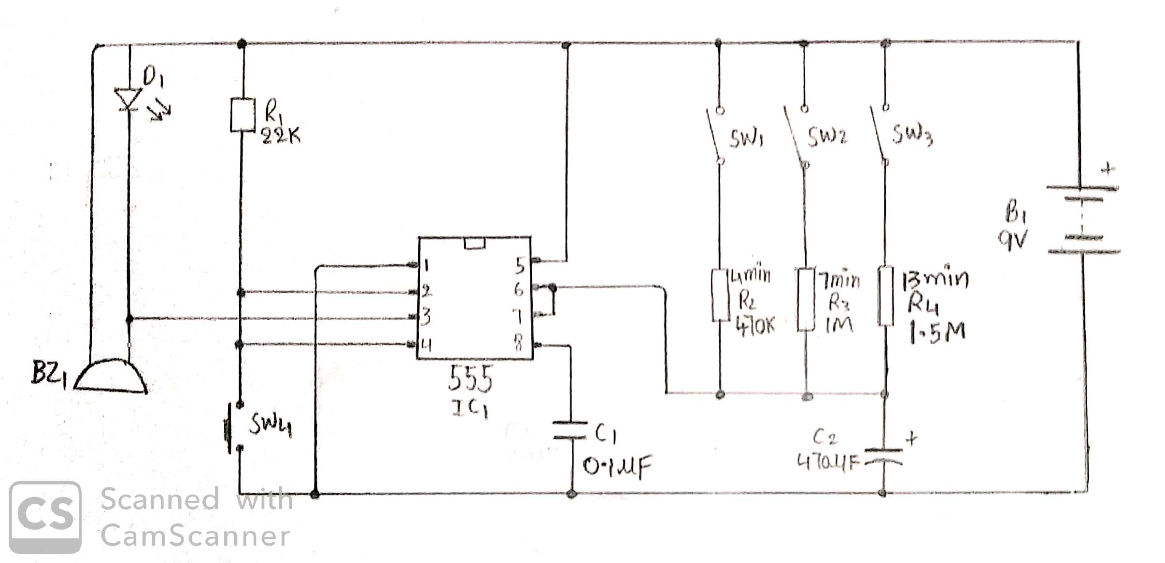

|  |  |  |  |
| --- | --- | --- | --- |
| Sl.no | Required  components | Remarks | Quantity |
| 1 | IC’S | NE555 | 1 |
| 2 | Piezo buzzer | BZ1 | 1 |
| 3 | LED | Red light | 1 |
| 4 | Capacitors | Ceramic  Electrolytic | 0.1uF  470Uf |
| 5 | Resistors | R1  R2  R3  R4 | 27k  500k  1M  1.5M |
| 6 | Battery | B1 | 9v |
| 7 | Switch | SW1  SW2  SW3  SW4 |  |

TB 1

**PROJECT DESCRIPTION**

**COMPONENTS:**

* IC,S
* RESISTOR
* POWER SUPPLY
* CAPACITOR
* PEZO ELECCTRIC BUZZER
* LED

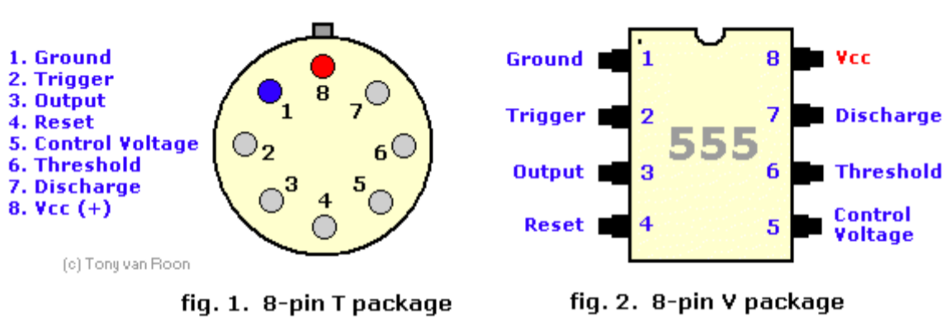**IC NE555:**

The timer IC 555 was introduced around 1971 by the company Signetics under the name SE555 / NE555 and was called "The Time Machine IC". It offered circuit designers a relatively inexpensive, stable and easy-to-use integrated circuit for monostable and astable applications. Since this device was first marketed, many unique and innovative circuits have been developed and presented in various commercial, professional and leisure publications. Over the past decade, some manufacturers have stopped making these timers for reasons of competition or other reasons. However, other companies, such as NTE (a sub-division of Philips) have resumed their activities where some have left.

Although the CMOS version of this IC, such as the Motorola MC1455, is primarily used, the standard type is still available, but many enhancements and variations have been made to the circuits. But all types are compatible with pin plugs. In this tutorial, the 555 timer is examined in detail, as are its uses, either alone or in combination with other semiconductor devices. This timer uses a labyrinth of transistors, diodes and resistors and, for this complex reason, a more simplified (but precise) block diagram is used to explain the internal organization of 555. The 555, in fig. 1 and FIG. 2 above, is available in two cases, either the round metal housing called "T", or the 8-pin DIP housing better known, "V". About 20 years ago, the type of canister was almost standard (SE / NE types). The 556 timer is a 555 dual version and comes in a 14-pin DIP package, the 558 is a quad version with four 555s also in a 14-pin DIP package.

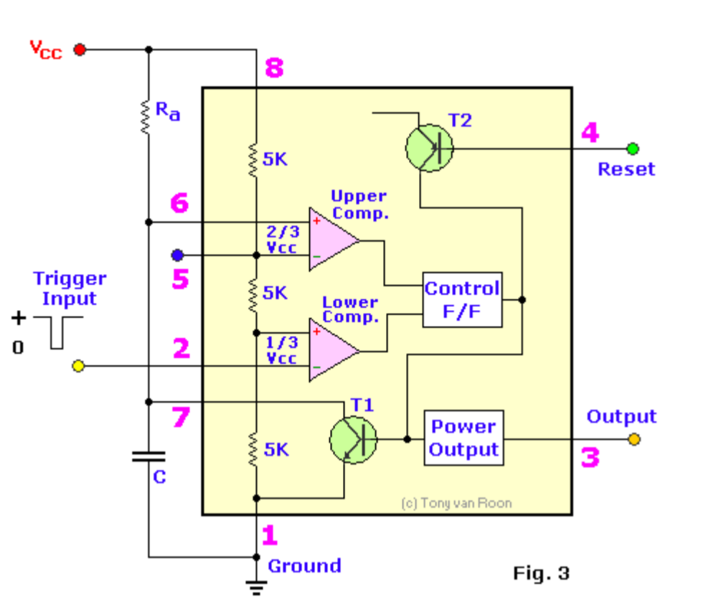

Inside the timer 555, in fig. 3, equivalent to more than 20 transistors, 15 resistors and 2 diodes, depending on the manufacturer. The equivalent circuit, in the form of a block diagram, provides the functions of control, triggering, detection or comparison of level, discharge and power output. The most attractive features of the 555 timer are: supply voltage of 4.5 to 18 volts, supply current of 3 to 6 mA and rise / fall time of 100 ns. The threshold current determines the maximum value of Ra + Rb. For operation at 15 volts, the maximum total resistance for R (Ra + Rb) is 20M

The supply current, when the output is "high", is generally less than or equal to 1 milliamp (mA). The initial monostable time precision is generally less than 1% of the calculated value and shows a nonsignificant drift (0.1% / V) with the supply voltage. Therefore, long-term feed changes can be ignored and the temperature change is only 50 ppm / ° C (0.005% / ° C). All IC timers depend on an external capacitor to determine the time intervals for deactivation of the output pulses. A finite period of time is required for a capacitor (C) to charge or discharge via a resistor (R). These times are clearly defined and can be calculated based on resistance and capacitance values.) It is 20 MΩ.

3.8 volts per second.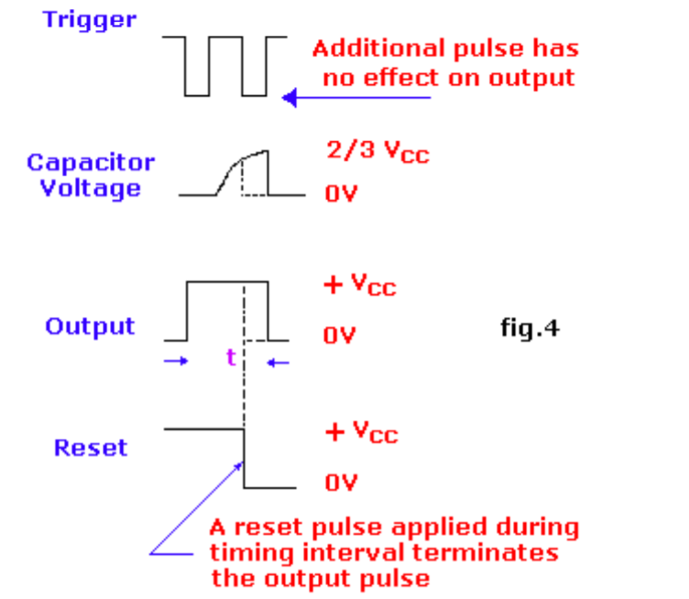

The basic RC load circuit is shown in fig. 4. Suppose the capacitor is initially discharged. When the switch is closed, the capacitor starts charging through the resistor. The voltage across the capacitor increases from zero to the value of the applied DC voltage. The load curve of the circuit is shown in fig. 6. The time required for the capacitor to charge at 63.7% of the applied voltage is called the time constant (t). This time can be calculated with the simple expression: t = R X C Suppose a resistance value of 1 MΩ and a capacitor value of 1uF. The time constant in this case is: t = 1,000,000 X 0,000001 = 1 second. Suppose also that the applied voltage is 6 volts. This means that it will take a time constant for the voltage across the capacitor to reach 63.2% of the applied voltage. As a result, the capacitor charges at approximately

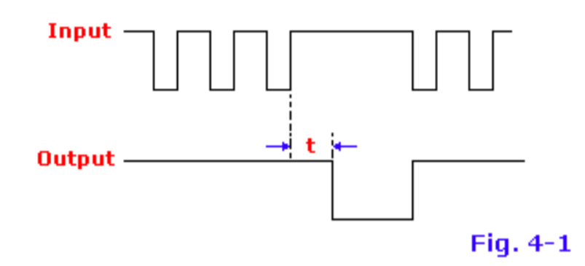

Fig. 4-1, changing the frequency of the input pulse makes it possible to terminate the synchronization cycle. As a general rule, the monostable time of 'ON' is set to approximately 1/3 more than the expected time between the activation pulses. Such a circuit is also called "lost pulse detector".

Looking at the curve of fig. 6. You can see that the capacitor needs about 5 full time constants to almost charge the applied voltage. The capacitor voltage takes about 5 seconds to reach about 6 volts maximum.

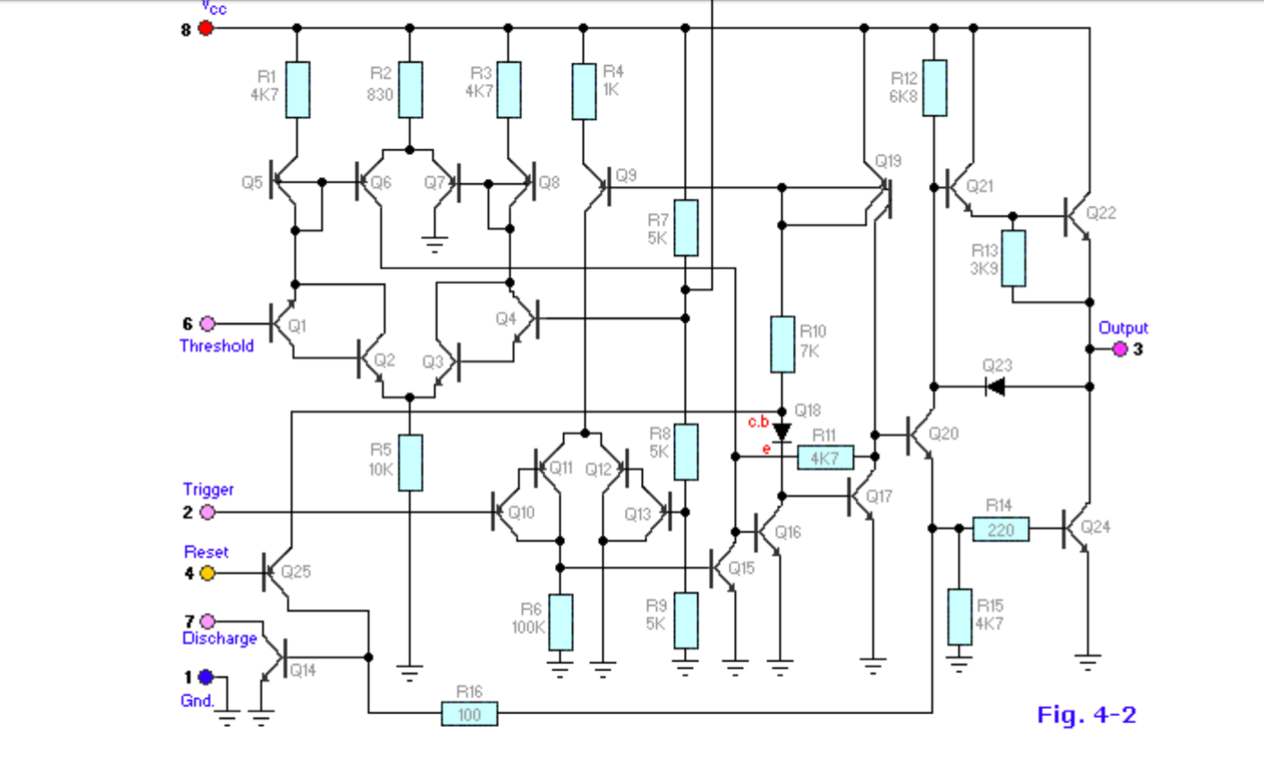

Definition of Pin Functions:

See internal diagram 555 in FIG. 4-2

Pin 1 (ground): The ground (or common) pin is the most negative power potential of the device, which is normally connected to the common (ground) circuit when operating from positive supply voltages.

Pin 2 (trigger): This pin is the input of the lower comparator and is used to adjust the latch, which makes the output high. This is the beginning of the time sequence in the monostable operation. The shot is obtained by taking the pin up and down with a voltage of 1/3 V + (or, in general, half of the voltage appearing on pin 5). The action of the activation input is level sensitive, allowing the use of slow change rate waveforms, as well as pulses, as activation sources. The trigger pulse must be shorter than the time interval determined by external R & C. If this pin remains low longer, the output will remain high until the trigger input increases again. A caution to observe with the trigger input signal is that it should not be less than 1/3 V + for a longer period than the synchronization cycle. If allowed, the timer will be reactivated at the end of the first output pulse. Therefore, when the timer is used in monostable mode with input pulses longer than the desired output pulse width, the input trigger must be effectively shortened by differentiation. The minimum pulse width allowed for activation depends to some extent on the pulse level, but in general if greater than 1uS (micro-second), the activation will be reliable. A second precaution concerning the trigger input refers to the storage duration in the lower comparator. This part of the circuit may have normal stopping delays of several microseconds after activation; that is, the lock may still have an activation input during this period after the activation pulse. In practice, this means that the minimum monostable output pulse width must be of the order of 10 μS in order to avoid possible double activation due to this effect. The voltage range that can safely be applied to the trip pin is between V + and ground. A DC current, called the tripping current, must also flow from this terminal to the external circuit. This current is usually 500nA (nano-amp) and will set the upper limit of allowable resistance of pin 2 to earth. For an astable configuration operating at V + = 5 volts, this resistance is 3 megaohms; It can be higher for a higher level of V +.

Pin 3 (output): output 555 is from a high current totem stage consisting of transistors Q20 to Q24. Transistors Q21 and Q22 provide a drive for source-type loads, and their Darlington connection provides a high output voltage of about 1.7 volts less than the V + power level used. Transistor Q24 offers the possibility of absorbing the current for low state loads called V + (as typical TTL inputs). The transistor Q24 has a low saturation voltage, which allows it to interact directly with a good noise margin when it performs the current reduction logic. However, the exact output saturation levels vary considerably with the supply voltage, for both high and low states. At a V + of 5 volts, for example, the low state Vce (sat) is typically 0.25 volts at 5 mA. However, when running at 15 volts, it can absorb 200 mA if a 2 volt output voltage level is allowed (the power dissipation must be taken into account in this case, of course). The high state level is typically 3.3 volts at V + = 5 volts; 13.3 volts at V + = 15 volts. The rise and fall times of the output waveform are quite fast, the typical switching times are 100nS. The state of the output pin will always reflect the opposite of the logic state of the latch, which can be seen by examining FIG. 3. Since the lock itself is not directly accessible, this relation can be better explained in terms of the activation activation lock conditions. To activate the output in the high state, the activation input is momentarily taken from a higher level to a lower level. [see "Pin 2 - Trigger"]. This causes locking and high output. The performance of the lower comparator is the only way to set the output high. The output can return to a low state by raising the threshold from a lower level to a higher level [see "Pin 6 - Threshold"], which resets the latch. The output can also be reduced by bringing the reset to a low state near the ground [see "Pin 4 - Reset"]. The output voltage available on this pin is approximately equal to the Vcc applied to pin 8 minus 1.7Vs.

Pin 4 (reset): This pin is also used to reset the latch and return the output to a low state. The threshold level of the reset voltage is 0.7 volts and a 0.1 mA dissipation current of this pin is required to restart the device. These levels are relatively independent of the V + level of operation; Thus, the reset input is compatible with TTL for any supply voltage. The reset input is a primary function. that is, it will force the output to a low state regardless of the state of the other inputs. Therefore, it can be used to prematurely terminate an output pulse, to block oscillations from "on" to "off", etc. The delay time between the restart and the output is generally of the order of 0.5 μS and the minimum width of the reset pulse is 0.5 μS. However, none of these numbers are guaranteed and may vary from manufacturer to manufacturer. In summary, the reset pin is used to reset the latch that controls the state of output pin 3. The pin is activated when a voltage level between 0 and 0.4 volts is applied to the pin. The reset pin will force the output to a low level, regardless of the state in which the other inputs of the flip-flop are located. When not in use, it is recommended to connect the reset input to V + in order to avoid the possibility of false restart.

Pin 5 (control voltage): This pin allows direct access to the 2/3 V + voltage division point, the reference level of the upper comparator. It also allows indirect access to the lower comparator because there is a 2: 1 splitter (R8 - R9) from this point to the lower comparator reference input, Q13. The use of this terminal is a user option, but it allows extreme flexibility by allowing the modification of the period, the restart of the comparator, etc. When timer 555 is used in a voltage controlled mode, its voltage operation varies from about 1 volt less than V + to 2 volts of mass (although this is not guaranteed). Voltages may safely be applied outside these limits, but must be limited within the V + and ground limits for reasons of reliability. By applying a voltage to this pin, it is possible to vary the duration of the device independently of the RC network. The control voltage can vary from 45 to 90% of the Vcc in monostable mode, which allows the output pulse width to be controlled independently of RC. When used in astable mode, the control voltage can vary from 1.7 V to full VDC. Variable voltage in astable mode will produce a modulated frequency (FM) output. If the control voltage pin is not used, it is recommended to ground it with a capacitor of about 0.01uF (10nF) for noise immunity because it is an input comparison. This fact is not evident in many 555 circuits since I have seen many circuits with "no-pin-5" connected to anything, but this is the proper procedure. The small ceramic lid can eliminate false activations.

Pin 6 (threshold): Pin 6 is an input of the upper comparator (the other is pin 5) and is used to reset the latch, resulting in low output. The reset through this terminal is made by taking the bottom terminal to a voltage of 2/3 V + (the normal voltage on pin 5). The action of the threshold pin is level sensitive, which allows slow rate of change waveforms. The voltage range that can safely be applied to the threshold pin is between V + and ground. A direct current, called the current threshold, must also reach this terminal from the external circuit. This current is generally 0.1 μA and will define the upper limit of total resistance allowed from pin 6 to V +. For any synchronization setting that operates at V + = 5 volts, this resistance is 16 MΩ. For operation at 15 volts, the maximum resistance value is 20 MΩ.

Pin 7 (discharge): this pin is connected to the open collector of an NPN transistor (Q14), whose emitter is grounded, so that when the transistor is activated, pin 7 is actually short-circuited to the mass. Generally, the sync capacitor is connected between pin 7 and ground and is discharged when the transistor is turned on. The state of attack of this transistor has a synchronization identical to that of the output stage. It is "on" (low resistance to earth) when the output is low and "off" (high resistance to earth) when the output is high. In the monostable and astable time modes, this transistor switch is used to ground the appropriate nodes of the synchronization network. The saturation voltage is generally less than 100 mV (millivolts) for currents of 5 mA or less, and the leakage in the off state is approximately 20 nA (however, these parameters are not specified by all manufacturers) . The maximum collector current is internally limited by design, thus eliminating capacitor size restrictions due to the maximum discharge of the pulse current. In some applications, this open-collector output can be used as an auxiliary output terminal, with a current-dissipating capacity similar to that of the output (pin 3).

Pin 8 (V +): Pin V + (also called Vcc) is the positive power supply terminal of the timer CI 555. The operating voltage supply range of the 555 is between +4.5 volts (minimum) and +16 volts (maximum). It is specified for operation between +5 volts and +15 volts. The device will operate essentially in the same way in this voltage range without changing the period. In fact, the most significant operating difference is the capacity of the output inverter, which increases for both the current and voltage ranges as the supply voltage increases. The sensitivity of the time interval to the variation of the supply voltage is low, typically 0.1% per volt. There are special and military devices operating at voltages up to 18 V.

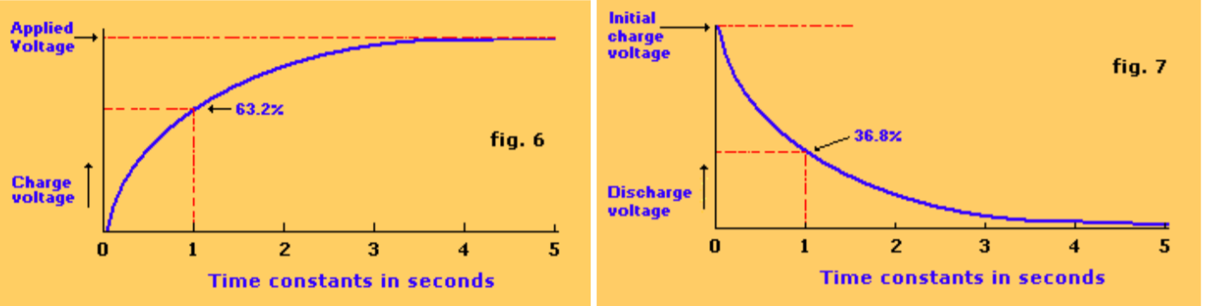

**555 Timer Bi-stable**

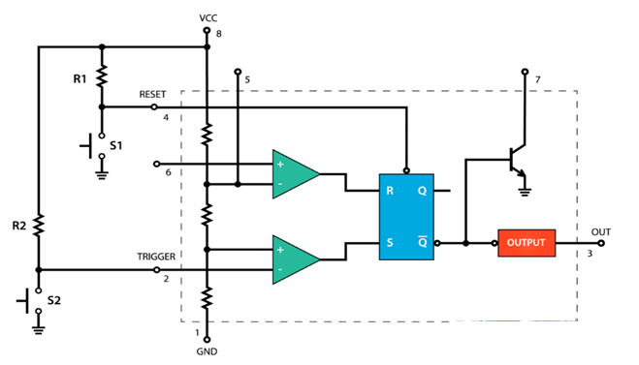

Fig.8

Let's look at an example of the 555 timer running in bi-stable mode. For this, we need two external resistors and two buttons.

The reset and reset pins of the integrated circuit are connected to VCC via the two resistors and are thus always high. Both buttons are connected between these pins and the ground. Therefore, if you hold them down, the input state will be low.

Initially, the two outputs of the comparators are 0, therefore, the output of the flip-flop and the output of the timer 555 are 0.

If we press the Trigger button, the state of the Trigger input becomes Low. The comparator emits a High signal, which causes an output of the low level of the Q bar of the reversal. The exit step will reverse this trend and the final output of the 555 timer will be high.

The output will remain high even if the trigger is not depressed because, in this case, the inputs of the R and S flip-flops will be at 0, which means that the flip-flop will not change the previous state. To make the output low, we have to press the reset button, which resets j and k flip-flops the entire integrated circuit.

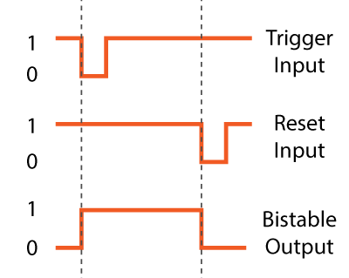

**555 Timer – Monostable Mode**

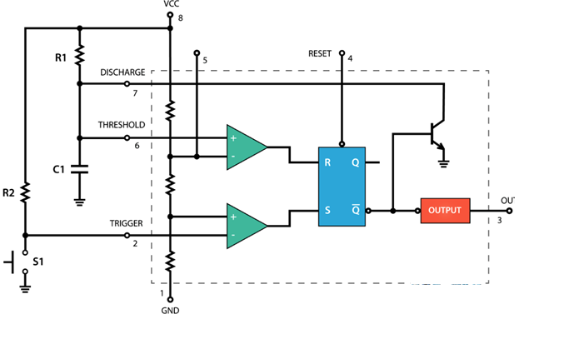**Fig 9**

Next, let's see how the 555 timer works in monostable mode. Here is an example of a circuit.

The trigger input is held high by connecting it to VCC via a resistor. This means that the trigger comparator will generate 0 at the S input of the flip-flop. On the other hand, the threshold pin is low and the threshold comparator is also equal to 0. The threshold pin is really low because the Q bar output of the flip-flop is high, which keeps the transistor active. discharge, so that the voltage that comes from the source will be grounded through this transistor.

To change the output status of the 555 timer to the high position, press the trigger pin button. This will set the activation pin to earth or the state of the input will be 0, so the comparator will send 1 to the S input of the flip-flop. This will reduce the output of the Q bar and the output of the timer 555. At the same time, we can note that the discharge transistor is off, so that the capacitor C1 will now start charging through the resistor R1.

The timer 555 will remain in this state until the voltage across the capacitor reaches 2/3 of the supplied voltage. In this case, the threshold input voltage will be higher and the comparator will send 1 to the input R of the flip-flop. This will bring the circuit to the initial state. The output of the Q bar will become high, which will activate the discharge transistor and will also cause the output of the integrated circuit.

Then, we can note that the time during which the output of the timer 555 is high depends on the time required for the capacitor to charge at 2/3 of the voltage supplied, and this depends on the values ​​of the capacitor C1 and the resistor R1. In fact, we can calculate this time with the

# following formula

# 555 Timer – Astable Mode

# Let's see how the 555 timer works in stable mode. In this mode, the integrated circuit becomes an oscillator or even called Free Running Multi vibrator. It has no stable state and continuously switches between High and Low without applying an external trigger. Here is an example of a 555 timer circuit running in stable mode.

# We only need two resistors and one capacitor. The trigger and threshold pins are connected to each other. No external trigger pulse is needed. Initially, the voltage source will begin charging the capacitor through the resistors R1 and R2. During charging of the tripping comparator, 1 is output because the input voltage on the tripping pin is always less than 1/3 of the supplied voltage. This means that the output Q bar is 0 and the discharge transistor is closed. At this point, the performance of the 555 timer is high.

# R1.put low again.

# 

Once the voltage at the terminals of the capacitor reaches 1/3 of the supplied voltage, the tripping comparator emits 0, but at this stage, it undergoes no modification, the inputs R and S of the flip-flops being equal to 0. The voltage Through the capacitor, it will continue to increase and once it has reached 2/3 of the supplied voltage, the threshold comparator will emit 1 to the R input of the flip-flop. This will activate the discharge transistor and the capacitor will now begin to discharge via resistor R2 and the discharge transistor. At this time, the output of the 555 Timer is low.

During the discharge, the voltage across the capacitor begins to decrease and the threshold comparator starts immediately at the output 0, which makes no change, since the inputs R and S of the flip-flop are now zero. Once the voltage across the capacitor drops to 1/3 of the supplied voltage, the trigger comparator emits 1. This turns off the discharge transistor and the capacitor starts charging again. Therefore, this process of charging and discharging between 2/3 and 1/3 of the supplied voltage will continue to operate on its own, producing a square wave at the output of the timer 555.

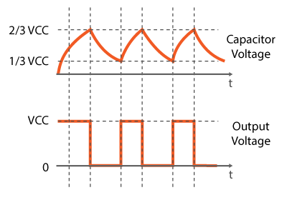

We can calculate the time in which the output is high and low using the formulas shown. The high time depends on the resistance of R1 and R2, as well as the capacity of the capacitor. On the other hand, the low time depends only on the resistance of R2 and the capacity of the capacitor. If we add the high and low times, we will get the period of a cycle. On the other hand, frequency is the number of times it happens in one second. Therefore, during the period, the frequency of the rectangular output will be used.

If we make certain modifications to this circuit, for example by modifying resistance R2 with a variable resistor or a potentiometer, we can instantly control the frequency and service cycles of the square wave. However, more about this in my next video where we are going to make a PWM DC motor speed controller using the 555 timer.

I hope you enjoyed this tutorial and learned something new. Feel free to ask questions in the comments section below.

Applications:

• There are literally thousands of ways to use the 555 in electronic circuits. However, in almost all cases, the basic circuit is simple or stable.

• The application typically requires a specific pulse duration, operating frequency, and duty cycle. Additional components may need to be connected to the 555 to interact

RESISTORS:

|  |  |
| --- | --- |
| Timer for Students | **2019** |

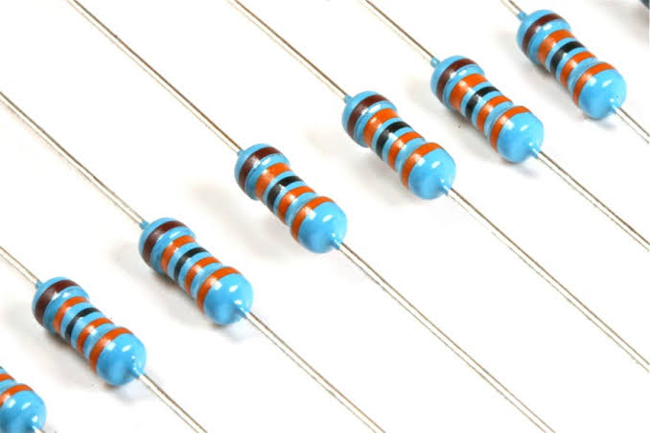

A resistor is a passive two-component electrical component that implements an electrical resistor as a circuit element. In electronic circuits, resistors are used to reduce current flow, adjust signal levels, divide voltages, bias active elements, and terminate transmission lines, among other uses. High power resistors that can dissipate many watts of electrical energy in the form of heat can be used in motor controls, in power distribution systems, or as test loads for generators. Fixed resistors have resistances that change only slightly with temperature, duration or operating voltage. Variable resistors may be used to adjust circuit elements (such as a volume control or lamp dimmer), or as devices for detecting heat, light, moisture, force, or chemical activity.

Resistors are common elements of electrical networks and electronic circuits and are ubiquitous in electronic equipment. Practical resistors as discrete components may be composed of various compounds and forms. Resistors are also implemented in integrated circuits.

The electrical function of a resistor is specified by its resistance: common commercial resistors are manufactured in a range of more than nine orders of magnitude. The nominal resistance value is within the manufacturing tolerance specified in the component.

There are two connections which electrical components are connected within the circuit- **series**and **parallel**. They consists of different colour codes: BBROYGBPGW

CAPACITORS:

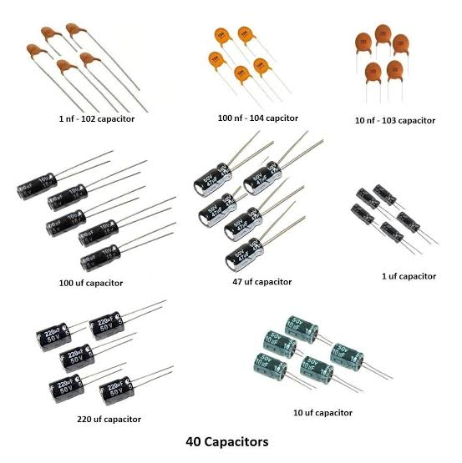

November 10, 2019

|  |  |
| --- | --- |
| Timer for Students | **2019** |

A capacitor is a device that stores electrical energy in an electric field. It is a passive electronic component with two terminals.

The effect of a capacitor is called capacitance. Although there is some capacitance between two nearby electrical conductors in a circuit, a capacitor is a component designed to add capacitance to a circuit. The capacitor was originally known as a capacitor or capacitor. The original name is still widely used in many languages, but not fluently in English.

The physical form and construction of the practical capacitors vary widely and many types of capacitors are commonly used. Most capacitors contain at least two electrical conductors often in the form of metal plates or surfaces separated by a dielectric medium. A conductor may be a sheet, a thin film, a sintered metal bead, or an electrolyte. The non-conductive dielectric acts to increase the capacitance of the capacitor.

Commonly used materials such as dielectrics include glass, ceramic, plastic films, paper, mica, air and oxide layers. Capacitors are widely used as parts of electrical circuits in many common electrical devices. Unlike a resistor, an ideal capacitor does not dissipate energy.

* When an electrical potential is applied, a voltage across a capacitor, for example when a capacitor is connected across a battery, an electric field develops across the dielectric, causing a net charge to accumulate on a base and a net negative charge. pick up on the other plate. No current actually flows through the dielectric. However, there is a charge flow through the source circuit. If the condition is maintained sufficiently, the current through the source circuit ceases. If a variable voltage is applied over time through the capacitor leads, the source experiences a DC current because of the charge and discharge cycles of the capacitorthe device to external circuits or devices.

November 10, 2019

POWERSUPPLY :

A power supply is a device that supplies electric power to a electric load .The term is most commonly referred to electric power converts that converts one form of electrical energy to another ,though it may also refer to that convert another form of energy ( mechanical chemical, solar) to electrical energy . The regulated power supply is that controls the output voltage or current to a specific value ;the controlled value is held nearly .

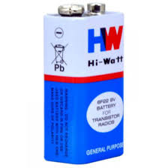

LED:

**A light emitting diode (LED)** is a two-lead semiconductor light source that resembles a basic pn-junction diode ,except that an led also emits light . When an LED’s anode lead has a voltage that is more positive than the cathode lead by at least the LED’s forward voltage drop ,current flows . Electrons are able to recombine with holes within the device ,releasing energy in the form of photons . This effect is called electroluminescence ,and the color of the light is determined by the energy band gap of the semiconductor

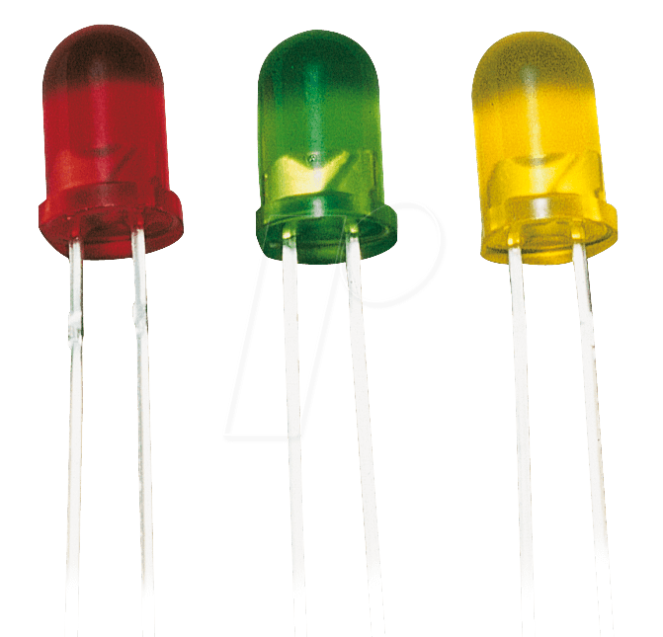

DIODE:

A diode is a two terminal electrical component that can conduct current in one direction as long as the diode operated in the specific voltage in reverse direction. the most common type of diode use as a pn junction. In this type of diode, in which (n) is electron charge carriers and second one (p)is holes (places depleted of electrons that act as positively charged particles)act as charge carriers a depletion region is formed across which electrons diffuse to fill holes p type. this stops the feature flow of electrons. When the junction is forward biased electrons can easily move across the junction to fill the holes, an a current flows through the diode. When the junction is reverse biased the depletion region widens and electrons cannot easily move across.

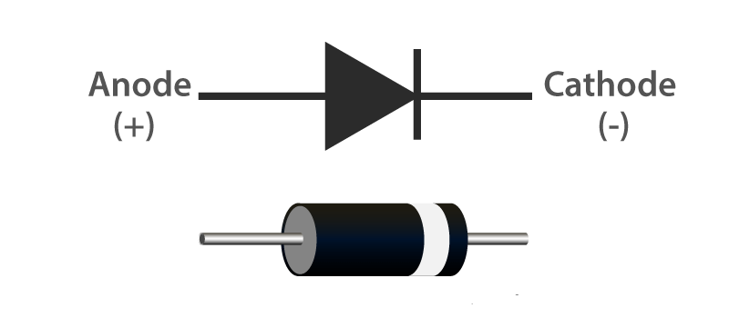

BUZZER:

A bell is a small but effective component to add sound functions to our project / system. It is a very small and compact 2-pin structure, so it can be easily used on the test card, Perf card and even cards, making it a widely used component in most electronic applications .

There are two types of bells commonly available. The one shown here is a simple bell that, once activated, will produce a continuous Beep sound ..., the other type is called a ready-to-use bell that will look bigger and will beep. Beep Sound due to the internal oscillating circuit present inside. But the one presented here is the most used because it can be customized using other circuits to easily adapt to our application.

This buzzer can simply be used when powered by a DC power source ranging from 4V to 9V. A single 9V battery can also be used, but it is recommended to use a regulated power supply of + 5V or + 6V DC. The ringer is normally associated with a switching circuit to activate or deactivate the ringer at the required time and interval.

BUZZER PIN CONFIGURATION

|  |  |  |
| --- | --- | --- |
| **Pin Number** | **Pin Name** | **Description** |
| 1 | Positive | Identified by (+) symbol or longer terminal lead. Can be powered by 6V DC |
| 2 | Negative | Identified by short terminal lead. Typically connected to the ground of the circuit |

Fg2

Buzzer Features and Specifications

* Rated Voltage: 6V DC
* Operating Voltage: 4-8V DC
* Rated current: <30mA
* Sound Type: Continuous Beep
* Resonant Frequency: ~2300 Hz
* Small and neat sealed package
* Breadboard and Perf board friendly

APPLICATIONS:

* Alarm circuits, where the user must be alarmed by something
* Communication equipment
* Car electronics
* Portable equipment, because of its compact size.

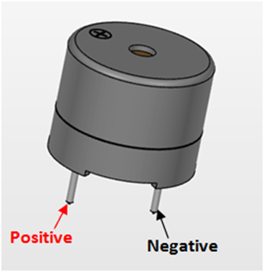

**CHAPTER 05**

**RESULT AND DISCUSSION**

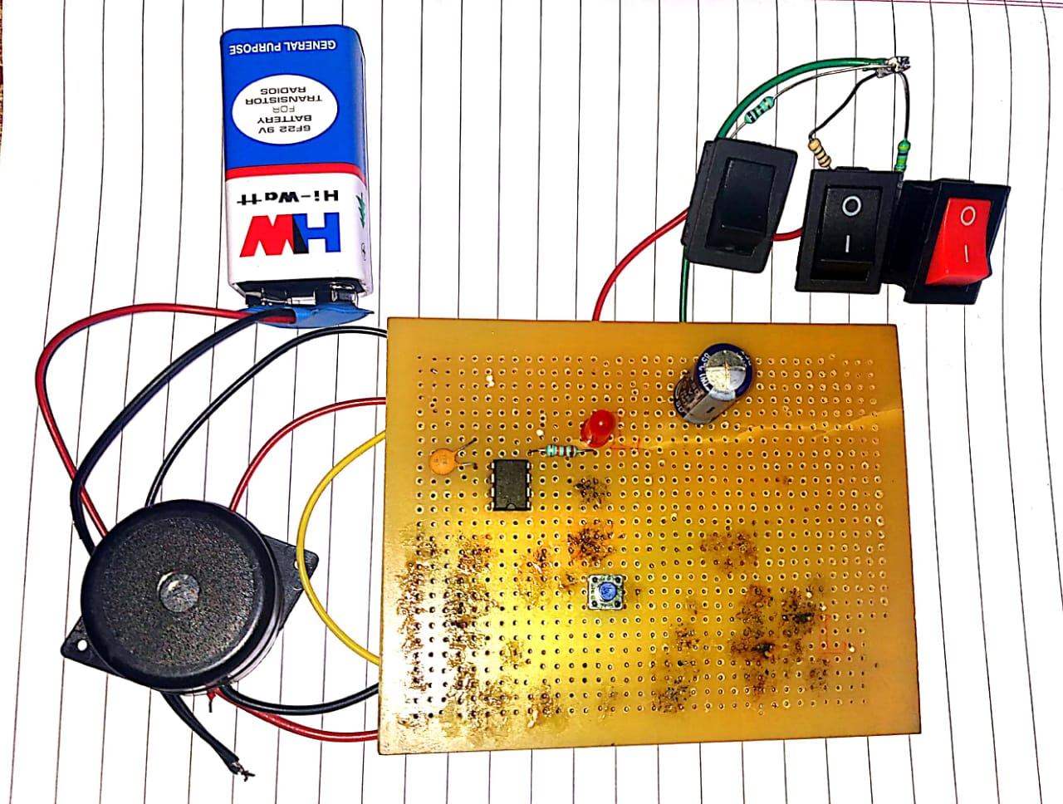

In this circuit first supply power by using battery and then reset the switch 4. In this circuit Switch 1 is connected 470k ,so it gives beep sound after 4 minutes then close SW1. Now switch on the SW2 again reset the SW4 after 7minutes SW2 resistor 1M gives beep sound after close SW2.Switch on the SW3 then reset SW4 after 13 minutes SW3 resistors 1.5M give sound.

**CHAPTER 06**

**CONCLUSION AND FUTURE SCOPE**

Now a days alarms became more important in our daily lives .This applicable to any institution where activities have to be carried out by various individuals in a specified time frame. From the time schools become organized environment, timetables have been the framework for all school activities. An effective time alarm is crucial for the satisfaction of education requirements and the efficient utilization of human. It is applicable to all set of people who need simple ne 555 timer alarm .

**Reference**

* FORREST MMIMS, “Timer, Op Amp, Optoelectronic Circuits& Project”, 21 February 2007.
* WALTER G JUNG,” IC Timer Cook Book”, 1977.
* FORREST MMIMS, “Science and Communication” 2004.

“Timer for Students”

N. Lakshmi Sai Mani Kanta

M. Sai Hemanth Reddy

M. Suresh

M. Chaitanya Kumar Reddy